P2 ImRec Project Planning Document

# Team Members

Emma Sutton

Kieron “Special K” Gillingham

Matt Dear

# Communication Methods

1. Mattermost Group
2. Discord Chat

# Research

* ANPR library <https://github.com/oskopek/javaanpr>
* JMS (Java Messaging System) <https://www.javatpoint.com/jms-tutorial>
* GitHub Actions/Circle CI
* GitHub Projects
* Docker/Docker Compose <https://docs.docker.com/compose/>

# Messages

**IN**: Image(ASCII), Image Reference, Camera Number, Timestamp

**OUT**: Number Plate, Image Reference, Camera Number, Timestamp

# Deployment

* Requirements of ANPR library (Java 1.5 or above)
* Docker/JAR?
* Docker Compose?
* Maven
* Ubuntu?

# Testing Requirements

* Test Scaling up on queue length
* Test tearing down on queue length
* Test JMS messages in/out
* Test converting ASCII image to JPG
* Test converting JPG to ASCII image

# Questions

1. P1(Image Receiving) - What are they giving us/what we need from them?
2. How are P1(Image receiving) converting images into an ascii format. We will be getting a URL of the image
3. P3(Reconcile Charging), P8 (Check MOT), P9 (Check Speeding) - What we can offer them and what they would like from us?
4. P4(DevOps) - How would they like us to scale? How to package out microservice?
5. What implementation of JMS will be using and whose decision is that? (<http://activemq.apache.org/>) Implementation of JMS needs to support queue length information to allow us to scale.

# Functional Requirements

Functional requirements define the basic system behaviour. Essentially, they are **what** the system does or must not do, and can be thought of in terms of how the system responds to inputs. Functional requirements usually define if/then behaviours and include calculations, data input, and business processes.

1. Receive messages from P1(Receiving Image Team) queue.
   1. Message Data (Image(ASCII), Image Reference, Camera Number, Timestamp).
2. With the image data (ASCII) convert it to an image format (JPG).
3. Recognise the number plate and add this to the object.
4. Send objects to P3 (Reconcile Charging Team) on exit as a queue.
   1. Message Data (Number Plate, Image Reference, Camera Number Timestamp)
5. Scale on high traffic from P1(Receiving Image Team) based on what is in the queue. (Docker/VMs)

# Non Functional Requirements

*non-functional* requirements specify **how** the system should do it. Non-functional requirements do not affect the basic functionality of the system (hence the name, *non*-functional requirements). Even if the non-functional requirements are not met, the system will still perform its basic purpose.

1. Destroy object from P1
2. Tear down on low traffic from P1(Receiving Image Team) based on what is in the queue. (Docker/VMs)

Things to do in meeting:

* Set up Github project? / No we are waiting for Craig to do this...
* Create diagram to explain our part of the system / Done Basic Diagram
* Create data flow diagram for our part of the system? / Done Message Diagram
* Complete non functional and functional requirements / Done
* Create a timeline of tasks that need to be completed and in what order. / Done Jira

First Presentation:

* How your component fits into the overall system
* Initial System model – information model, messaging and components (Class diagram)
* Functional and non-functional feature requirements
* Test requirements
* Deployment requirements
  + Describe the precise, desired configuration of a software system. They relate the system's non functional **requirements** to its architecture, providing a basis for making decisions about design trade-offs in terms of the resulting system's non functional properties.
* Outline project plan

Presentation one:

# How our part of the system fits into the overall project:

Questions to be asked

Who will code and de code the images?

# Functional Requirements:

1. Receive messages from P1(Receiving Image Team) queue.
   1. Message Data (Image(ASCII), Image Reference, Camera Number, Timestamp).
2. With the image data (ASCII) convert it to an image format (JPG).
3. Recognise the number plate and add this to the object.
4. Send objects to P3 (Reconcile Charging Team) on exit as a queue.
   1. Message Data (Number Plate, Image Reference, Camera Number Timestamp)
5. Scale on high traffic from P1(Receiving Image Team) based on what is in the queue. (Docker/VMs)

# Non Functional Requirements:

1. Destroy object from P1
2. Tear down on low traffic from P1(Receiving Image Team) based on what is in the queue. (Docker/VMs)

# Testing Requirements:

* Selection of images
* ActiveMQ plugin
* Access to Java ANPR library

# Testing

* Test Scaling up/down on queue length
* Test JMS messages in/out
* Image recognition

How will we test with other teams?

How will we test these things?

# Deployment Requirements

* ActiveMQ server
* Deployment location
* Access to Java ANPR library
* We need to make a docker image for use downstream
* Need a properties file that can be injected to talk to the ActiveMQ server.
* Properties can setup how many threads we are running.

# Class Diagram:

# Use Case Diagrams:

# Message Model:

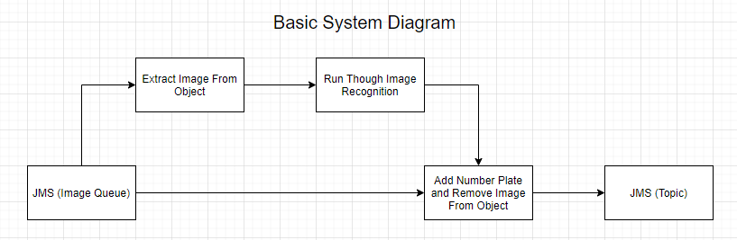

# Outline of Project Plan: